**Project Plan**

***Video call system for third year internship***

Pension worker and retiree’s enjoyer



|  |
| --- |
| **Date : 4 september 2023** |
| **Version : 1.1** |
| **State : Base project done** |
| **Author : Tony Jiang** |

#### Version history

|  |  |  |  |  |
| --- | --- | --- | --- | --- |
| **Version** | **Date** | **Author(s)** | **Changes** | **State** |
| 0.1 | 4 Sep 23 | Tony Jiang | Initial start of document | In progress |
| 0.2 | 7 Sep 23 | Tony Jiang | Make some correction and fix spell checks | In progress |
| 1.0 | 12 Sep 23 | Tony Jiang | Fix spell checks | Approved by company mentor and first assessor.  Base project done |
| 1.1 | 18 Sep 23 | Tony Jiang | Add title to sprint in 3.2.  Add a new risk in 5.1.  Fix spell checks | Base project done |
| 1.2 | 26 Sep 23 | Tony Jiang | Fix spelling errors | Done |
| 1.3 | 3 Oct 23 | Tony Jiang | Update the end product diagram | Done |

**Distribution**

|  |  |  |
| --- | --- | --- |
| **Version** | **Date** | **Receivers** |
|  |  |  |
|  |  |  |

Contents

1. Project assignment 4

1.1 Context 4

1.2 Goal of the project 4

1.3 Scope and preconditions 4

1.4 Strategy 5

1.5 Research questions and methodology 5

1.6 End products 6

2. Project organisation 7

2.1 Stakeholders and team members 7

2.2 Communication 7

3. Activities and time plan 9

3.1 Phases of the project 9

3.2 Time plan and milestones 9

4. Testing strategy and configuration management 10

4.1 Testing strategy 10

4.2 Test environment and required resources 10

4.3 Configuration management 10

5. Risk 11

5.1 Risk and mitigation 11

# Project assignment

## Context

The company called ITP Caribbean tasked me to create 2 or 3 solutions for a video call system for their application. ITP stands for Information Technology Partners. They provide IT solutions in consultation for their customers. ITP Caribbean is in Rumbastraat in Oranjestad, Aruba. The Company activities are IT Consultancy, developing software solutions, network administration services and ICT health care. They’re currently working with one of their largest clients, SVb (Sociale Verzekeringsbank in Aruba) to create a video call system on the application. The application is called PRAS, it stands for Pensioen Registratie en Administratie Systeem.

## Goal of the project

* Why is the project being done?

Currently one of the pension departments have to determine if the retirees that live abroad are still alive. The determination if a person is still alive, is done by using a WhatsApp video call facility on a tablet, which is a bit of a hassle to do. The tablet has to be operational and up to date. The employees have to search for the retired person on WhatsApp, which requires a bit of manual work and could be error prone.

* What would the new preferred situation look like?

The preferred situation is to have the video call system on the PRAS application system, to have everything easy to access and easy to use in one system. The calls will be logged automatically when the call is started and ended and at what time the call has taken place and by which employees.

* What are the advantages of this project?

The advantages of this project are to provide accuracy and efficiency to the SVb employees who needs to make a call video to the retirees that are living abroad. The system will also reduce human errors.

* How does this project add value to the company/context?

The project adds value to reduce the use of tablets and reduce the cost to buy new tables and maintain it. They only need to use the PRAS application system to manage the video calls and everything they need to do for checking up on retirees is on the PRAS application.

* Which possibilities does the ICT product offer that the project will realize?

ICT products offers a better way to make a video call on the PRAS application. It also offers hands in in the application, no more external technology, or software to make e video call to the retirees.

## Scope and preconditions

|  |  |
| --- | --- |
| **Inside scope:** | **Outside scope:** |
| 1. Come up with 2 or 3 solutions for video call system. | 1. Implement the prototype project in production. |
| 1. Create the prototypes on the PRAS application. | 1. Pay acquisition of subscription for making a video call. |
| 1. Familiarize with the application and the process. |  |
| 1. Ensuring code quality and test |  |
| 1. Create wireframe |  |
| 1. Create research document |  |
| 1. Create C4 architecture diagram |  |
| 1. Create an implementation guide. |  |

The preconditions

1. Make the prototypes on the PRAS system.
2. Make use of company laptop, it has all the environments set up to make the prototypes.
3. Use VB.net to program the prototypes.
4. IDE is Visual Studio.
5. Version management is TortoiseSVN.

## Strategy

The approach for the project of building a video call system for the PRAS application can be an agile approach like scrum. Scrum is a popular project management framework that is designed to deliver high-quality software in an iterative and incremental manner. The Scrum methodology is ideal for complex projects with rapidly changing requirements, which is applicable in the case for a video call system.

The Scrum approach will enable me to deliver value quickly by breaking down the project into smaller chunks called sprints. Each sprint will deliver a working piece of software that can be demonstrated to the stakeholders. This allows for constant feedback and course correction throughout the project, which will help ensure that the system meets the needs of all stakeholders. Additionally, the Scrum methodology promotes transparency and collaboration amongst the stakeholders, which will help keep everyone aligned and working towards a common goal.

In contrast to a traditional waterfall approach, where each phase of the project is completed before moving on to the next, the Scrum approach encourages continuous development and testing. This helps to identify issues and problems early in the project, which can be addressed quickly, reducing the risk of costly rework later on.

In summary, the Scrum approach is suitable for the video call system project as it allows for flexibility, constant feedback, and collaboration, ultimately leading to a higher quality end product that meets the needs of all stakeholders.

## Research questions and methodology

* Research question 1: How should the video call facility work in the PRAS system?

Methodology: Document analysis, Interview

This is to look at the documentation on what the client (SVb) wants based on the interview they did

with the company (ITP Caribbean) or any information that the company has gathered and documented.

Interviewing the company on any information or questions about the PRAS system or the video call

system is also helpful.

* Research question 2: Which video call systems are there?

Methodology: Available product analysis, Literature study, Brainstorm.

This is to look if there are any available products online, like any information to make a video call system.

Any general information and best practices in making a video call system is helpful. Also, to come up with

some ideas on how to make a video call system.

* Research question 3: Which video call system can be implemented based on the requirements?

Methodology: IT architecture sketching, Requirements list, Prototyping.

IT architecture sketching is to get an idea on how everything is set up and how it would be implemented,

with the requirements in mind. Build a prototype would also give more insight on how to implement a

video call system into the application to make other possible video call system prototype for the

application.

* Research question 4: Which video call system benefits a better user experience?

Methodology: Usability testing, Unit test, Persona.

This is to test out everything from unit test, acceptance test, usability test for any unexpected issue

That could happen with the users while using the video call system. Acting as a certain user that is going

to use the application is also helpful, to get an idea on what the user is experiencing when using the

video call system and to help in improving it as much as possible.

## End products

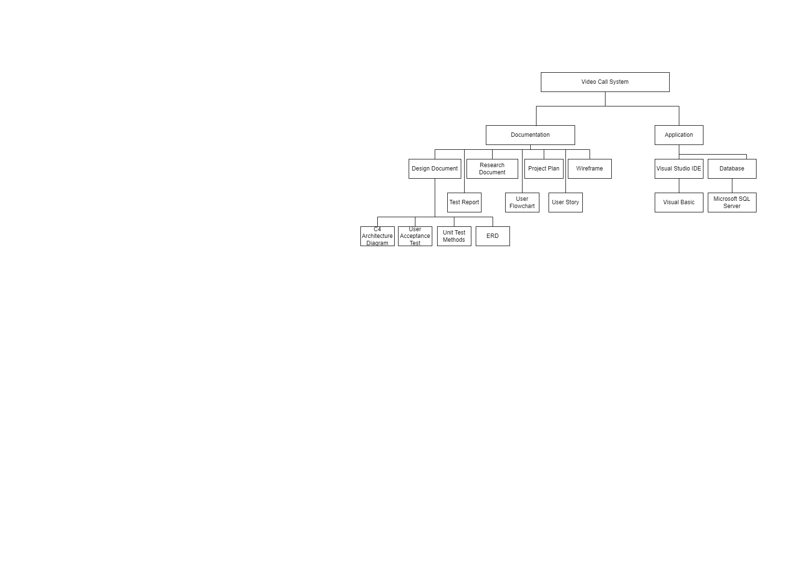

# Project organisation

## Stakeholders and team members

|  |  |  |  |  |
| --- | --- | --- | --- | --- |
| **Name** | **Contact** | **Abbreviation** | **Role and functions** | **Availability** |
| Edwin Roos | [e.roos@itpinternational.com](mailto:e.roos@itpinternational.com) | E. | Company mentor | Monday to Friday from 8:00 till 17:00 (Arubian time) |
| Olga Makoveeva | [o.makoveeva@fontys.nl](mailto:o.makoveeva@fontys.nl) | O. | Frist assessor (University tutor) | Thursday 3:00 till 6:00 (Arubian time) |
| Tony Jiang | [t.jiang@student.fontys.nl](mailto:t.jiang@student.fontys.nl) or [T.Jiang@itpinternational.com](mailto:T.Jiang@itpinternational.com) | T.N.P. | Intern developer | Monday to Friday from 8:00 till 17:00 (Arubian time) |
| Jerry Gomez | [J.gomez@itpinternational.com](mailto:J.gomez@itpinternational.com) | J.G. | Developer | Monday to Friday from 8:30 till 17:00 (Arubian time) |
| Ahnille Christiaans | [a.christiaans@itpinternational.com](mailto:a.christiaans@itpinternational.com) | A.C. | Developer | Monday to Friday from 7:30 till 15:30 (Arubian time) |
| Zair Thiel | [z.thiel@itpinternational.com](mailto:z.thiel@itpinternational.com) | Z.T. | Developer | Monday to Friday from 7:30 till 15:30 (Arubian time) |
| Jason Croes | [j.croes@itpinternational.com](mailto:j.croes@itpinternational.com) | J.C. | Software Quality Officer | Monday to Friday from 7:30 till 15:30 (Arubian time) |

## Communication

Meeting with the company mentor

* Location: On company building.
* When: If available on Monday to Friday from 8:00 till 17:00
* Goal:
* For questions, if something isn’t clear.
* For help, if help is needed to fix any issue or to figure out a solution.
* For feedback on how everything is going on the project.

Meeting with the first assessor

* Location: Teams meeting.
* When: Planned date first.
* Goal:
* For questions, if there is an issue.
* For weekly meetings on how the project is going.

Meeting with colleagues, developer

* Location: On company building
* When: If available to on Monday to Friday from 8:00 till 17:00
* Goal:
* For asking questions and assistance with something.

# Activities and time plan

## Phases of the project

The phases of the project are in sprints. Each sprint I have to deliver and present the product to the company mentor. Each sprint takes 3 working weeks before the end of the internship. The whole project should be finished in 7 sprints. Below it is possible to see the supposed milestones and correlating activities for the project.

* Sprint 1: Initial planning and research – Plan and create every document that is needed to create the project and do some research on the project.
* Sprint 2: Setup and get acquainted with the initial environment and continue to do research – Setup everything that is needed to start programing on the project and get acquainted with everything new that is needed for the application. Also continue to do research on the project.
* Sprint 3: Making the prototype – Start making prototypes of the project.
* Sprint 4: Improve, implement, and create new prototype – Improve the project and implement some stuff based on the feedback and create new prototype for another solution.
* Sprint 5: Improve and implement – Improve and implement based on the feedback.
* Sprint 6: Improve and implement - Improve and implement based on the feedback.
* Sprint 7: Finish up everything – Finish everything up from the project.

## Time plan and milestones

|  |  |  |  |
| --- | --- | --- | --- |
| **Phasing** | **Start date** | **Finish date** | **Start week to end week (not school base)** |
| 1. Sprint 1: Initial planning and research | 4 Sep 2023 | 22 Sep 2023 | 1-3 |
| 1. Sprint 2: Setup and get acquainted with the initial environment and continue to do research | 25 Sep 2023 | 13 Oct 2023 | 4-6 |
| 1. Sprint 3: Making the prototype | 16 Oct 2023 | 3 Nov 2023 | 7-9 |
| 1. Sprint 4: Improve, implement, and create new prototype | 6 Nov 2023 | 24 Nov 2023 | 10-12 |
| 1. Sprint 5: Improve and implement | 27 Nov 2023 | 15 Dec 2023 | 13-15 |
| 1. Sprint 6: Improve and implement | 18 Dec 2023 | 5 Jan 2024 | 16-18 |
| 1. Sprint 7: Finish up everything | 8 Jan 2024 | 26 Jan 2024 | 19-21 |

# Testing strategy and configuration management

## Testing strategy

* Unit test: This test will be used to test the code behavior. The unit test will be done for each functionality.
* User acceptance test: This test will be used to check if the stories acceptance criteria were met.

## Test environment and required resources

Environments

* The tests are performed on a local machine (laptop) from the company.
* The company’s test server

Tools

* Postman

## Configuration management

The company uses SVN to manage all their source code. SVN stands for Apache Subversion or also known as Subversion. Subversion is a revision control system, which is being use for managing changes to the computer programs, documents, large websites, or other collections of information.

SVN workflow

Tools

* TortoiseSVN or VisualSVN
* Working copy of repo: This contains a working copy of the main repository.

# Risk

## Risk and mitigation

|  |  |  |
| --- | --- | --- |
| **Risk** | **Prevention activities** | **Mitigation activities** |
| 1. Sick, health checkups or personal reason. | Eat healthy, call, or make an appointment with the company mentor, so that they know. | If you can work at home when sick. Work extra time that you have lost and schedule it with the company mentor. |
| 1. The branch you’re working on has a problem, can’t commit, or has an error | Commit every new change each day as much as possible, learn the habit to commit new changes. | . Revert the prevision version and start over again. |
| 1. Company mentor or first assessor isn’t available due to personal reason or sick. | Do not leave everything for the last moment. Assume that this kind of situation might happen. | Ask the company mentor or first assessor when they are available. Schedule a meeting as soon as possible. |
| 1. Falling behind on the deadline for the deliverables. | Always check on the agile scrum board on what to deliver on that sprint and the deadline. | Work overtime to fulfill the deliverables and let the company mentor know, to come up with a solution for this |
| 1. Programing environment has an error or problem. | Ask colleagues for help on how to fix it and or find a solution online. | Let the company mentor know, so that we can come up with a solution for this problem. |
| 1. Company mentor leaving the company for personal reason. | No action can be taken. | Let the first assessor know about this and ask colleague for help on who to talk to about this to find a solution for this. |
| 1. Client isn’t available to answer some question, because of problem or sick, etc. | Plan a head of time, or make a monthly meeting schedule, for some questions if possible. | Re-evaluate the questions with the company and reenact the questions with the company and find the answer to the questions. |
| 1. Waiting for colleagues or someone to use a function or a part of the system for the project. | Work on something else. | Ask them when they will be finished or plan something together to work around it. |